**PREDICTED DEMAND SPIKES**

**COLAB LINK:** <https://colab.research.google.com/drive/1ETrNoCCoo1X3-jghvBB-mbRucV0hOd9Y#scrollTo=83-xNV--izhN>

Exploratory Analysis: Warehouse Department

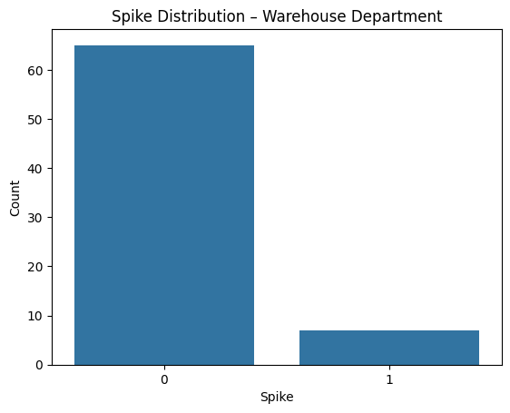

Top 5 Spike-Prone Items in Warehouse Department:

**item_name**

* Oil Filters 2
* Radiators 2
* Hydraulic Pumps 1
* Track Chains 1
* Bucket Teeth 1

Name: count, dtype: int64

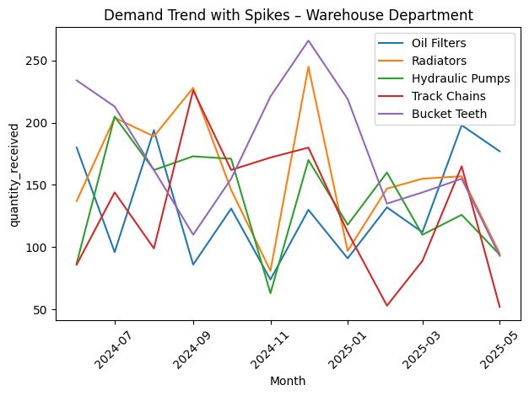

Exploratory Analysis: Sales Department

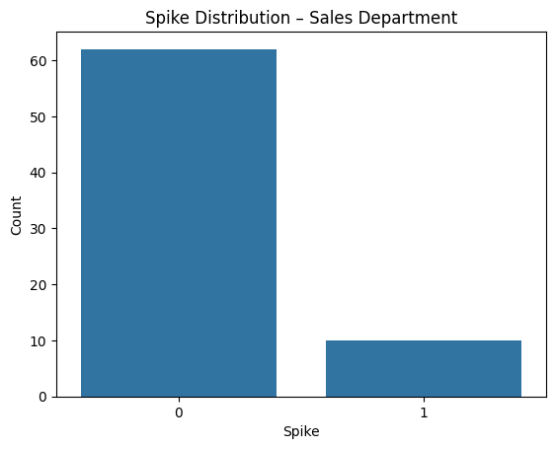

Top 5 Spike-Prone Items in Sales Department:

**item_name**

* Bulldozer 2
* Motor Grader 2
* Concrete Mixer 2
* Concrete Spraying Machine 2
* Excavator Long Arm 2

Name: count, dtype: int64

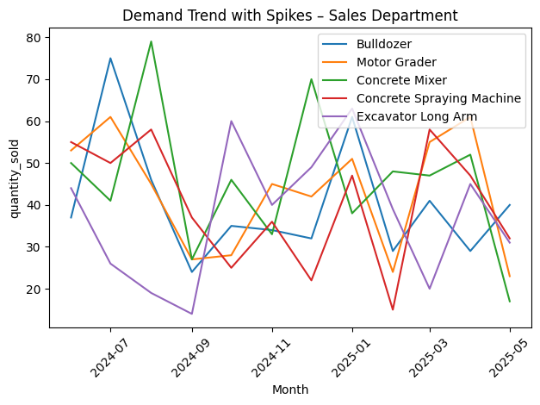

Warehouse Department Classification Report:

|  |  |  |  |  |
| --- | --- | --- | --- | --- |
|  | **precision** | **recall** | **f1-score** | **support** |
| **0** | 0.91 | 1.00 | 0.95 | 20 |
| **1** | 0.00 | 0.00 | 0.00 | 2 |
|  | | | | |
| **accuracy** |  |  | 0.91 | 22 |
| **macro avg** | 0.45 | 0.50 | 0.48 | 22 |
| **weighted avg** | 0.83 | 0.91 | 0.87 | 22 |

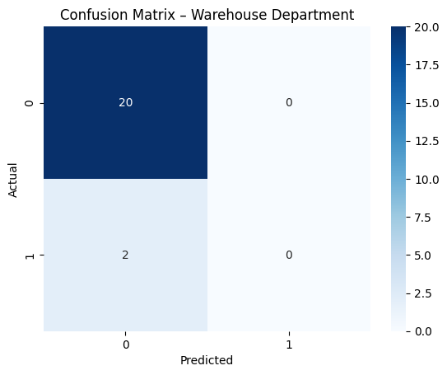

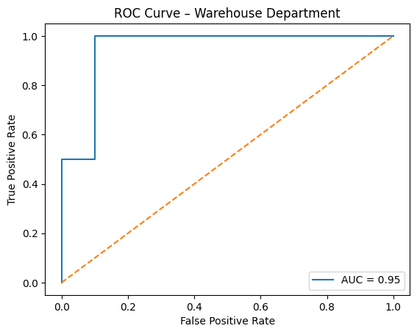

Sales Department Classification Report:

|  |  |  |  |  |
| --- | --- | --- | --- | --- |
|  | **precision** | **recall** | **f1-score** | **support** |
| **0** | 1.00 | 1.00 | 1.00 | 19 |
| **1** | 1.00 | 1.00 | 1.00 | 3 |
|  | | | | |
| **accuracy** |  |  | 1.00 | 22 |
| **macro avg** | 1.00 | 1.00 | 1.00 | 22 |
| **weighted avg** | 1.00 | 1.00 | 1.00 | 22 |

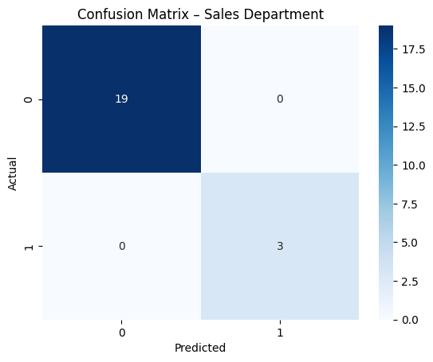

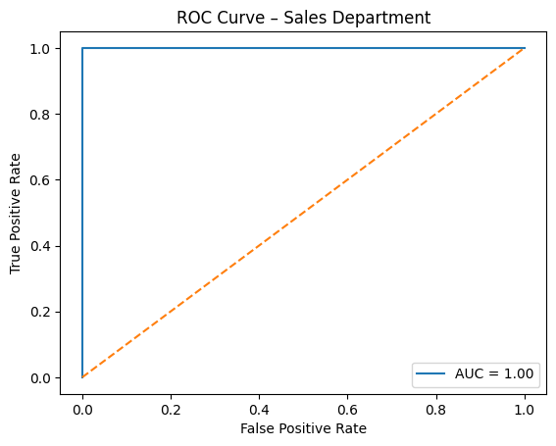

**GENERAL EXPLANATION**

The code predicts demand spikes (sudden sales surges) in two departments:

* 🏗️ Sales Department (Heavy Equipment)
* 🧰 Warehouse Department (Spare Parts)

This is done through binary classification:

* Will there be a spike this month for an item? Yes (1) or No (0)?

Steps:

1. Upload + clean the CSVs
2. Convert dates and aggregate data by month
3. Label each month as "Spike" or "No Spike" based on historical averages
4. Visualize trends and spikes
5. Train a Logistic Regression model to predict spikes
6. Evaluate performance (accuracy, precision, recall, ROC curve, confusion matrix)
7. Extract insights that Jinyi Inc. can actually use for inventory, supply chain, etc.

**LINE-BY-LINE EXPLANATION**

